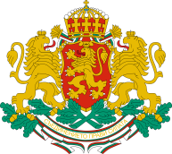 | CONSULATE GENERAL OF THE REPUBLIC OF BULGARIA  IN NEW YORK

NEWSLETTER (23 February – 28 April)
Everyone is invited to the following events co-organized by the Bulgarian Consulate General in New York:

February 23th, 6.00 pm: Presentation of the book “Житиеписецът“ / “The Biographer”, written by Stefan Kisyov. The conversation will be in Bulgarian!

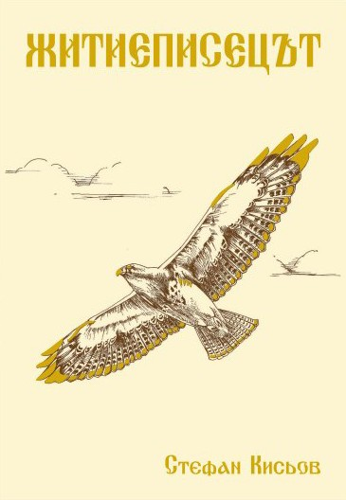

February 28th, 6.30 pm: Music for Strings from Central Europe, an event organized by the Bulgarian Concert Evenings in New York. For more information and booking of a free ticket visit our Facebook profile.

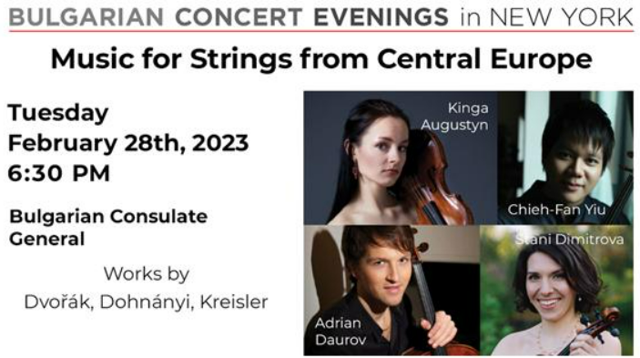

March 4th, 11.30 am: A flag raising ceremony on the occasion of the Bulgarian National Day at Bowling Green (next to the Bull of Wal Street). The Bulgarian and the American flags will be raised, the national anthems will be performed, and there will be a few Bulgarian folk dances (хоро), which will be joined by the guests of the event.

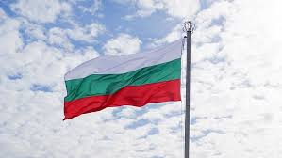
- March 7th, 6.30 pm: Movie night – „Humble”/ „Смирен“, directed by Svetoslav Draganov (will be present at the screening, together with a few of the actors). The movie is in Bulgarian with English subtitles.

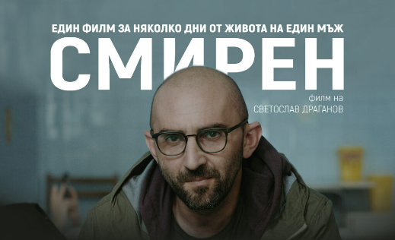

March 16th, 6.00 pm: Movie night – „Holiday Makers”/ „Летовници“, directed by Ivaylo Penchev, cameraman Hristo Bakalov (will be present at the screening). The movie is in Bulgarian with English subtitles.

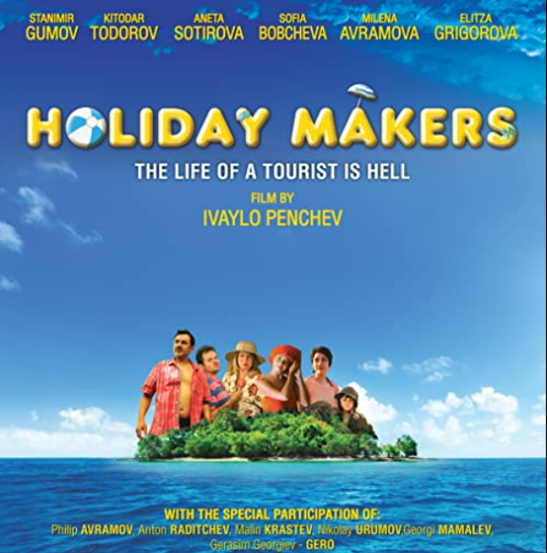

March 22nd, 6.30 pm: Trios for violin, viola and piano (Alexandrina Boyanova, violin, Mujan Hosseinzadeh, viola, Peter Fancovic, piano), an event organized by the Bulgarian Concert Evenings in New York. For more information and booking of a free ticket visit our Facebook profile.

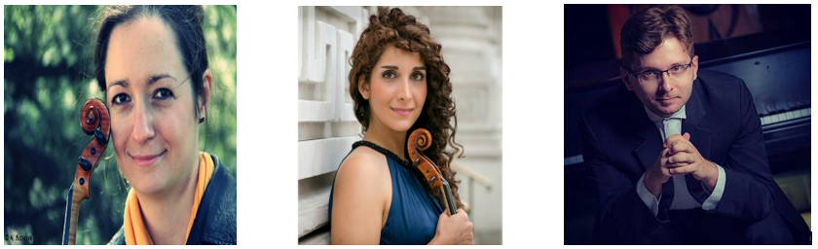

March 30th: A commemorative event on the occasion of the 80th anniversary of the rescue of the Bulgarian Jews during WWII will take place at the Center for Jewish Studies. The event will include musical program featuring Bulgarian and US Jewish composers, an overview of the relevant historic context and a brief presentation of a film. More information will be posted in due time in the social media profile of the Consulate General.

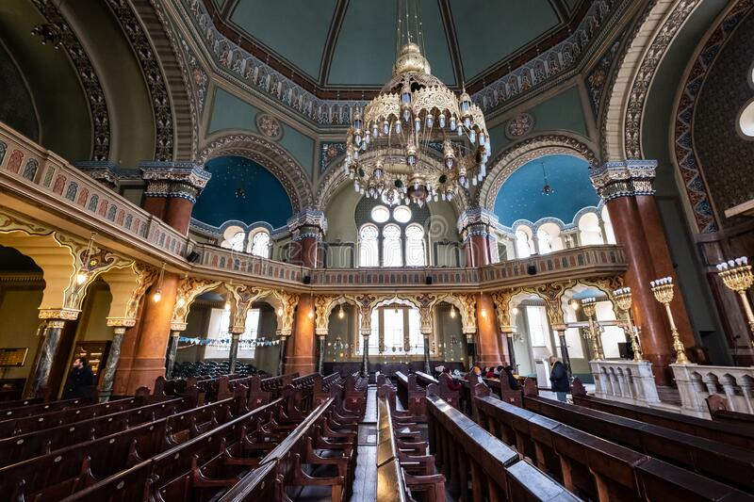
- April 2nd: Out of country voting – Bulgarian Parliamentary elections. A polling station will be set up at the Consulate General in New York.



April 18th, 6.00 pm: Spring Benefit Concert for Bulgarian Concert Evenings in New York featuring Bill Vasilev and Friends in a Latin Jazz Evening. For more information and booking of a free ticket visit our Facebook profile.

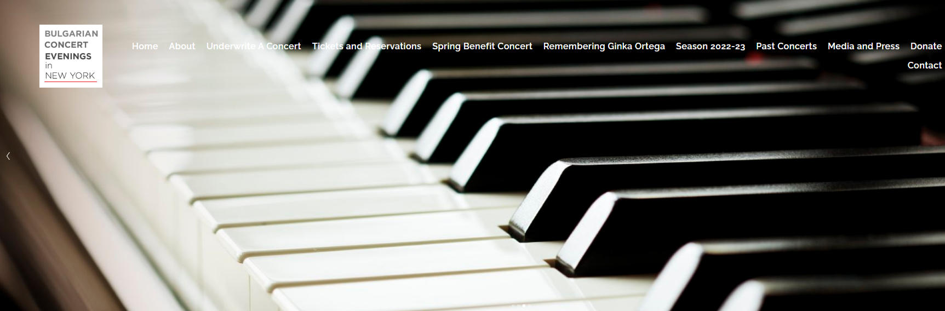

April 25th, 6.00 pm: Movie screening – “A question of survival”, directed by Elka Nikolova (will be present at the screening).

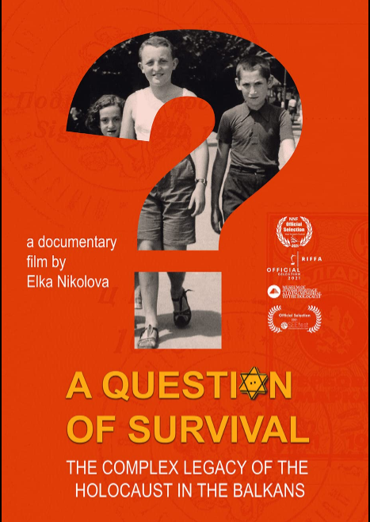

April 28th, 6.00 pm: Jazz concert with Lyubomir Denev.

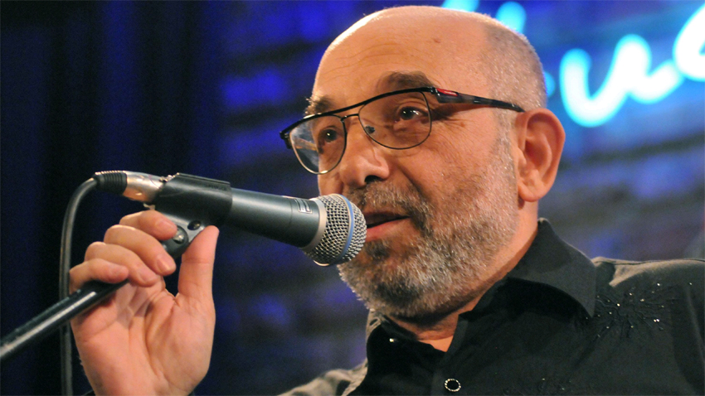
Relevant information about the activities of the Consulate General is regularly posted through at social media accounts:
Генерално Консулство Ню Йорк | Facebook
Consulate General of Bulgaria in New York | New York NY | Facebook
Consulate General of Bulgaria in New York 🇧🇬🗽 (@ConsulateBGinNY) / Twitter

